Eclipse Git Tutorial
Lars Vogel (c) 2009, 2017 vogella GmbH version 4.3, 28.11.2017

Git with Eclipse (EGit). This tutorial describes the usage of EGit; an Eclipse plug-in to use the distributed version control system Git.
 Get the book!

- 1. Git support for Eclipse
- 2. Command line Git
- 3. Installation of Git support into Eclipse
- 4. How to configure the usage of Git in Eclipse
  - 4.1. Interoperability of Git command line settings with the Eclipse IDE
  - 4.2. Git user settings in Eclipse
  - 4.3. Default clone location
  - 4.4. Configuring the toolbar and the menu for Git usage
- 5. Using the Git Repositories view
  - 5.1. Using the Git Repositories view
  - 5.2. Content in the Git Respositories view
  - 5.3. Open a commit
  - 5.4. Commands available in the Commit Viewer
- 6. Git integration into the Package and the Project Explorer
- 7. Using the Git Staging view
- 8. Using the Git commit dialog
- 9. Using the History view
  - 9.1. Purpose of the history view
  - 9.2. Review the repository history via the History view
  - 9.3. The History view filters
  - 9.4. Using search
  - 9.5. Showing details of a commit
- 10. Working with Eclipse projects in a Git repository
  - 10.1. Workspace and projects
  - 10.2. Adding a new project to a Git repository
- 11. Clone an existing repository
- 12. Import projects from an existing repository
- 13. Performing Git operations in Eclipse
  - 13.1. Pull, push and fetch
  - 13.2. Basic team operations
  - 13.3. Team operations available on the project
  - 13.4. Amending a commit
- 14. Branching in Eclipse
- 15. Starting a merge operation in Eclipse
  - 15.1. Merge
  - 15.2. Solving merge conflicts
- 16. Rebasing a branch onto another branch
- 17. Git reset and Git reflog
  - 17.1. Moving the branch pointer with Git reset
  - 17.2. Finding "invisible" commits with the Reflog view
- 18. Using git cherry-pick
- 19. Creating patches
- 20. See Git information line by line (aka git blame)
- 21. Stash via the Git repository view
- 22. Adjusting the history with interactive rebase
  - 22.1. Support for interactive rebase in Eclipse
  - 22.2. Actions available via the History view
  - 22.3. Using the Git Interactive Rebase view
- 23. Using Eclipse Git with GitHub
  - 23.1. Clone project
  - 23.2. Push changes
- 24. Eclipse support for SSH based authentication
- 25. Eclipse integration with GitHub
  - 25.1. GitHub issue integration
  - 25.2. Manage pull requests in Eclipse
  - 25.3. Import projects directly from GitHub
  - 25.4. More infos about the GitHub Mylyn integration
- 26. Writing good commit messages
  - 26.1. Importance of Git commit messages
  - 26.2. Guidelines for useful commit messages
  - 26.3. Example message
  - 26.4. Good and bad example for a Git history
- 27. Exercise: Working with a local Git repository in Eclipse
  - 27.1. Create a new Git repository via Eclipse
  - 27.2. Create .gitignore file
  - 27.3. Creating an Eclipse project
  - 27.4. Put project under version control
  - 27.5. Using the Git Staging view for the initial commit
  - 27.6. Using the Git Staging view for committing changes
  - 27.7. Commit more files
  - 27.8. Review your commit history via the History view
  - 27.9. Open an older version with the current version of a file via the History view
  - 27.10. Add more projects to your Git repository
  - 27.11. Validate the project move and commit changes
- 28. Contributing to EGit - Getting the source code
- 29. Eclipse Git Resources
- 30. vogella training and consulting support
- Appendix A: Copyright, License and Source code

1. Git support for Eclipse
The Eclipse IDE has excellent support for the Git version control system. This support is provided by the EGit project via a set of plug-ins (software component).
Eclipse uses the JGit library to perform the Git commands. JGit is a library which implements the Git functionality in Java.
The Eclipse Git user guide is bundled with the Eclipse Git installation. You can invoke it via Help Help Contents EGit Documentation.
The Eclipse workspace and Git repositories
It is good practice to place your Git repositories outside the Eclipse workspace. This separates your Git repository from any additional meta-data which Eclipse might create. By default, Eclipse Git uses the git folder in the users home directory to clone new repositories. This default location can of course be adjusted, see Default clone location for more information on this.

2. Command line Git
This tutorial describes the usage of EGit. If you want to learn about the usage of the Git command line, you can use the Git Tutorial as a reference.
This tutorial also explains the basic Git terminology, e.g., what is a commit, branch, etc.

3. Installation of Git support into Eclipse
Most Eclipse IDE distributions from Eclipse.org already contain support for Git. In this case no additional installation is required.
Otherwise you can install it via the Eclipse installation manager. Select the Help Install new Software…​ menu entry. Enter one of the following update site URLs:
# Use this update site to get the latest release
http://download.eclipse.org/egit/updates

# use this update site to get the night build
http://download.eclipse.org/egit/updates-nightly/
The dialog to install the Eclipse Git team provider is depicted in the following screenshot.
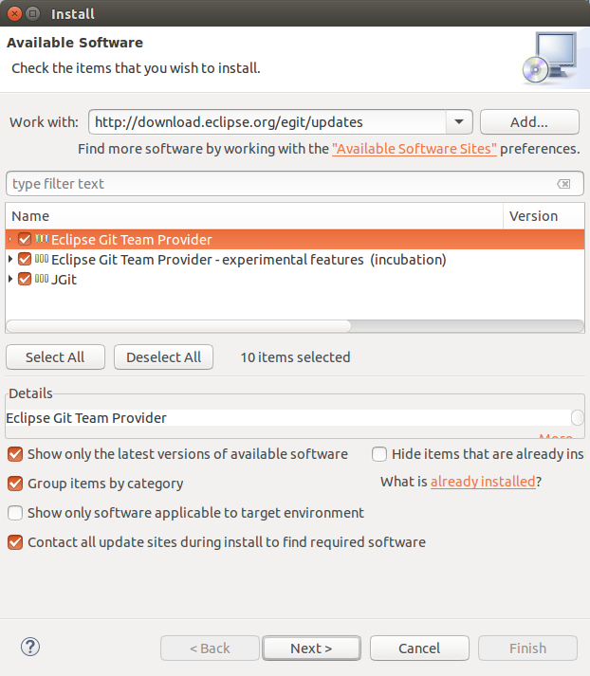

4. How to configure the usage of Git in Eclipse

4.1. Interoperability of Git command line settings with the Eclipse IDE
The Git functionality in the Eclipse IDE uses the same configuration files as the Git command line tools. This makes it easier to use the Eclipse Git tooling and the command line tooling for Git interchangeable. One notable exception is currently the support of gitattributes. See Bug 342372 - support gitattributes for details.

4.2. Git user settings in Eclipse
To use Git you must configure your full name and email address. This information is used to fill the author and committer information of commits you create. These Git configuration settings can be adjusted via the Eclipse preference setting. Select Window Preferences Team Git Configuration to see the current configuration and to change it.
See [eclipsegit_userconfiguration] for a detailed description how to configure Git via Eclipse.

4.3. Default clone location
If you clone a new repository via Eclipse Git, it will create by default a new sub-folder for the new Git repository in a default directory. This default path can be configured via the Windows Preferences Team Git entry in the Default Repository folder field.
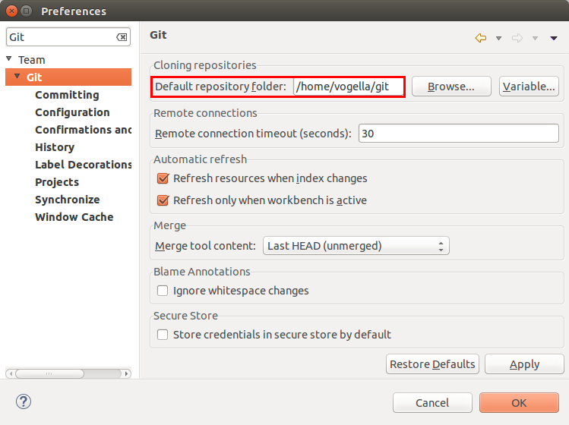
You can also use Eclipse configuration variables to define this path, e.g., if you want to store repositories in the folder "git" under the Eclipse workspace you may use ${workspace_loc}/git.

4.4. Configuring the toolbar and the menu for Git usage
To simplify access to the common Git operations you can activate the Git toolbar. For this select Window Perspective Customize perspective…​ and check the Git and Git Navigation Actions entries in the Action Set Availability tab.
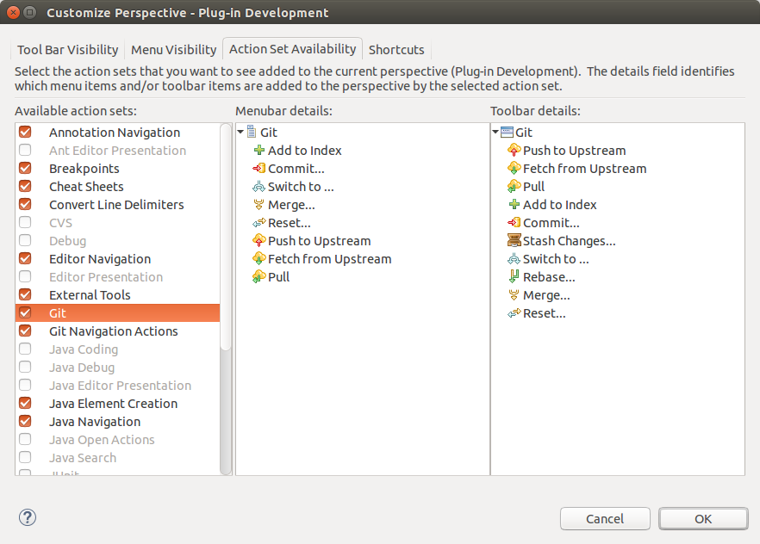
Afterwards you can configure which Git operations should be available via the Tool Bar Visibility or the Menu Visibility tab.
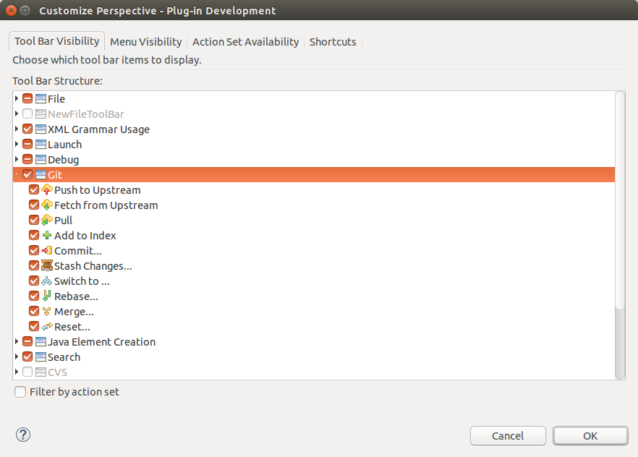

5. Using the Git Repositories view

5.1. Using the Git Repositories view
Eclipse Git provides the Git Repositories view which allows you to browse your repositories, add or initialize local repositories or clone remote repositories, checkout projects, manage your branches and much more. You can open this view via Window Show View Other…​ Other…​ Git Git Repositories
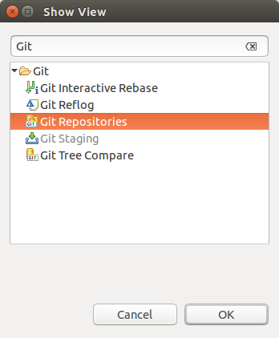
The toolbar entries allow you to add an existing local Git repository to the view, clone a Git repository and to create a new Git repository.
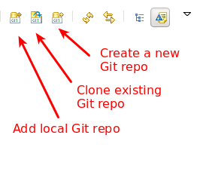

5.2. Content in the Git Respositories view
The content area of the Git Repositories view shows the existing Git repositories and the important data of each repository. The following screenshot shows an example Git repository.
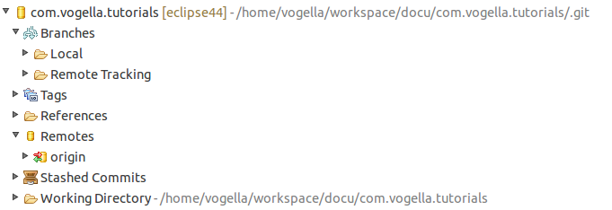
A right-click (context menu) on an element in the Git repositories view allows you to perform related Git operations. For example if you right-click on a branch you can checkout the branch or delete it.
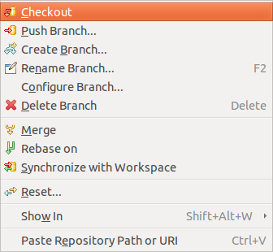

5.3. Open a commit
If you are in the Git repositories view you can open a commit via the main Eclipse menu. To do this select the Navigate Open Git Commit menu entry.
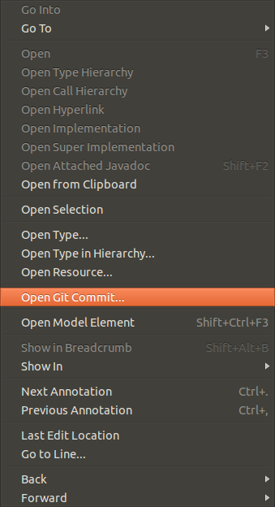
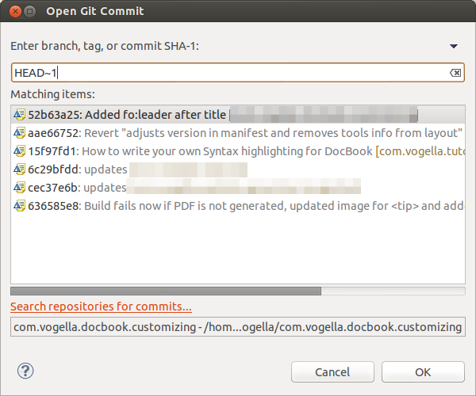

5.4. Commands available in the Commit Viewer
If you open a commit you can create a tag or branch from it. You can also revert it, cherry pick it or check it out. You can also reveal it in the history view.
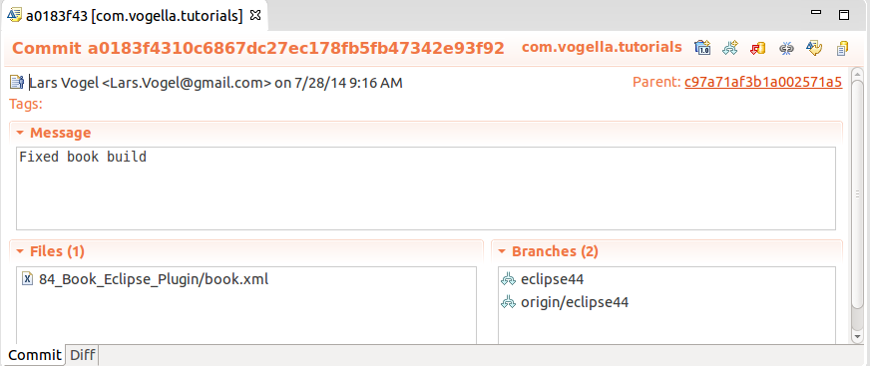

6. Git integration into the Package and the Project Explorer
The Package Explorer view shows indicators on the files to show their status. The most important icon decorators are depicted in the following screenshot.
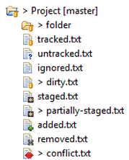
The file name describes the state of the file from the following table:
Table 1. Git label decorations
State | Description
tracked | File is committed to the Git repository and has not changed.
untracked | File is neither staged nor committed.
ignored | File is flagged to be ignored by Git operations.
dirty | File has changed since the last commit.
staged | Changes in the file will be included in the next commit.
partially-staged | The resource has changes which are added to the index and additional unstaged changes in the working tree
added | Staged but not yet committed, i.e. snapshot of this file has been stored in the git database. This status is the same as the staged status, but the file wasn’t under Git version control before.
removed | The resource is staged for removal from the Git repository.
conflict | A merge conflict exists for the file.
A combination of the staged and dirty status means: some parts of the changed file have been staged while some are still unstaged. This can happen if you stage a file and then again modify the file before creating the next commit. You can also change the staged parts using the compare editor opened by double clicking files in the staging view.
On a project level the explorer view adds the information which Git repository is used to the project name. It also adds the number of commits that are different between local and remote tracking branch. This way you can quickly see if your local branch is ahead or behind the remote branch it is tracking.
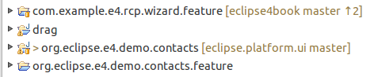

7. Using the Git Staging view
Eclipse gives you several options to stage and commit your changes. The Git Staging view provides a convenient compact overview on all changes you have done compared to the current HEAD revision.
This view presents which files you have touched and which files will be included in the next commit. Unstaged Changes lists those changes which you have done locally but which you have not yet added to the staging area. Staged Changes list those changes which you already have added to the staging area. You can drag and drop files from one area to the other. To commit the staged changes you write your commit message and press the Commit button which is highlighted in the following screenshot.
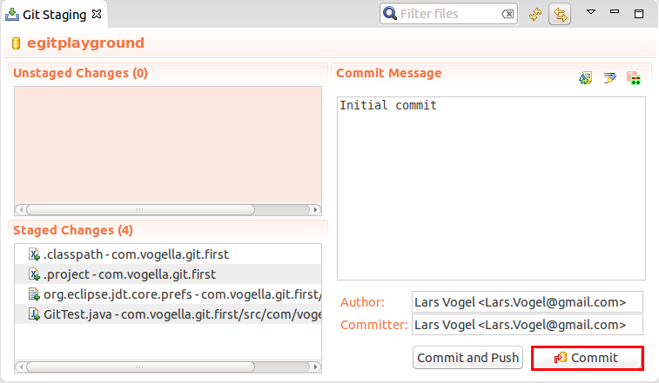
You can switch between different repositories or even restart Eclipse without losing a commit message and it allows incremental staging for changes.
You can open the Git Staging view via the Window Show View Other…​ Git Git Staging menu.

8. Using the Git commit dialog
You can also commit changes with the Git commit dialog. For this right-click on a resource and select Team Commit from the context menu.
The dialog allows you to add changed and new files to the staging area and commit the changes.
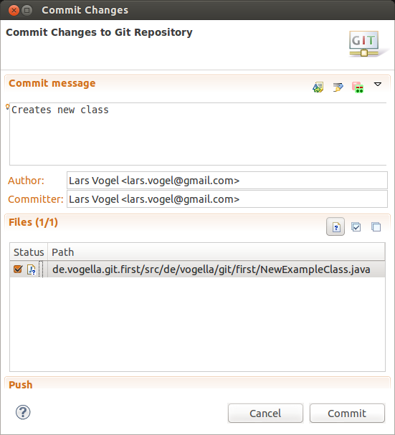
The commit dialog does not allow committing the removal of a file, since the commit dialog ignores the Git index.

9. Using the History view

9.1. Purpose of the history view
The History view allows you to analyze the history of your Git repository and to see to which commits the branches and tags points. This view displays author, date, commit message and the modified files of a commits.
This view is depicted in the following screenshot.
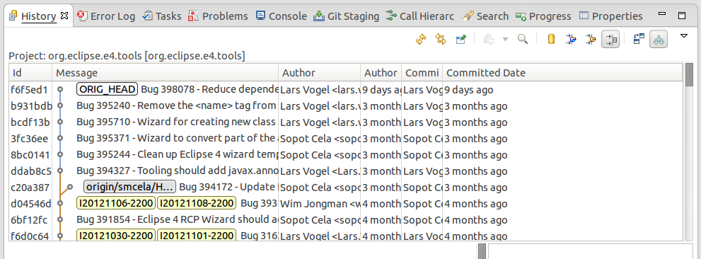
You can open this view via Window Show View Other…​ Team History. Alternatively you can open it via the repository node in the Git Repositories view. For this click on the Show In History entry. Some views, e.g., in the Java EE-Perspective, do not have this shortcut, in this case use Team Show in History.

9.2. Review the repository history via the History view
To see the history of a resource, select your project, a file or a folder, right-click on it and select the Show in> History context menu entry. Alternative you can use the Alt+Shift+W shortcut and select the History entry.
You can also configure the History view to display the history of the current selection. Select the highlighted button in the following screenshot for that.
If you select a commit you see the commit message and the involved files.
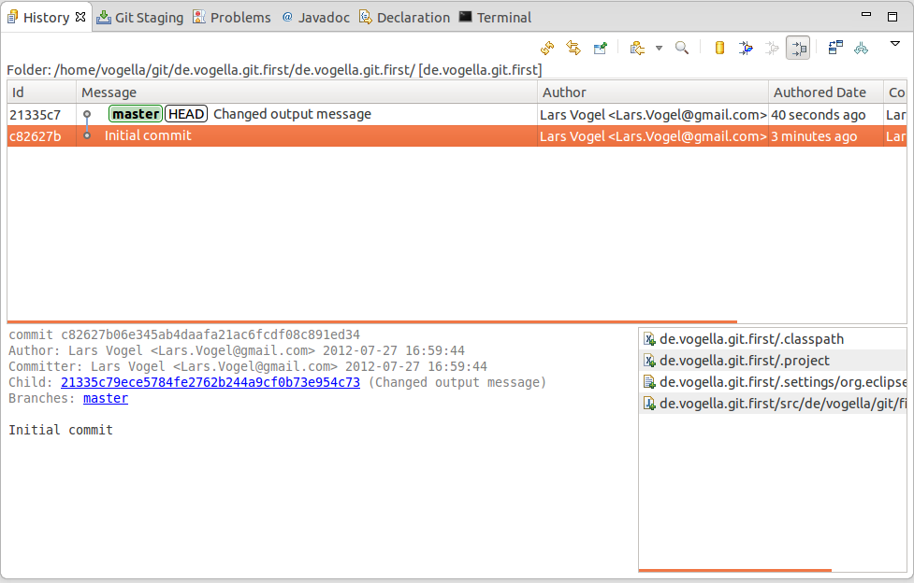
Via right-click on an individual file you can compare this file with its ancestor (the commit before that) or with the current version in the workspace.
If the "compare mode" toggle is selected from the view menu of the History view you can also double click a file to compare it to the previous version.
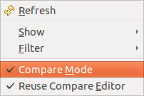

9.3. The History view filters
The History view has quite some options to configure which commits are displayed. Its toolbar allows you to customize which commits are displayed. By default, the History view filters the history based on the current selection and shows only the active branch.
If you work with several branches, e.g., because you are using Gerrit for code reviews, you typically want to see all branch information and remove the filter based on the resource.
The History view allows you to filter based on resources. See the tooltips of the toolbar for the meaning of the different filter options. In order to see all commits click the highlighted buttons with the Show all changes in this repository and Show all branches and tags tooltips.
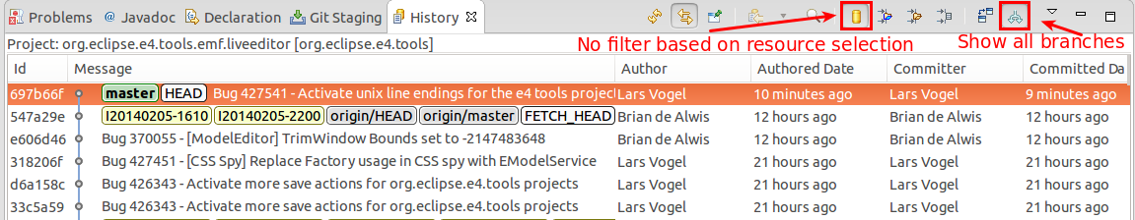
The following listing gives an overview of the purpose of the different buttons.
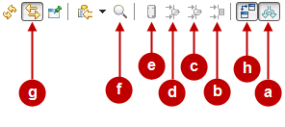
Depending on your use case you may want to select the following option:
- show only those commits which are reachable from the current branch. Hide all commits on other topic branches.
- see only those commits which changed the selected resource (file, project, subfolder) or it’s children. E.g. display only those commits which touched the selected java file. The current selection is shown in the top right corner of the History view.
- see only those commits which changed anything in the parent folder of the selected resource (file, project, subfolder) or it’s children. E.g. display only those commits which changed the same package as the selected java source.
- see only those commits which changed anything in the same project as the selected resource or it’s children. Used when you are working in a repository which contains multiple projects.
- don’t filter at all. Show all commits of the current repository
The options b., c. and d. are tied to the currently selected resource. Button g. allows that the history view automatically updates when you change the selection.
If you got lost with the different filters and the history doesn’t show what you expect, set it back to show everything. Therefore make sure that Show all branches and tags (a) is turned on and Show all changes in repository (e) is selected.

9.4. Using search
You can also search for commits based on committer, author, ID or comment. For this turn on the Show Find toolbar (f) and type in a search string in the Find field. The commits fitting to your search are highlighted. You can combine this search with the filters explained above.
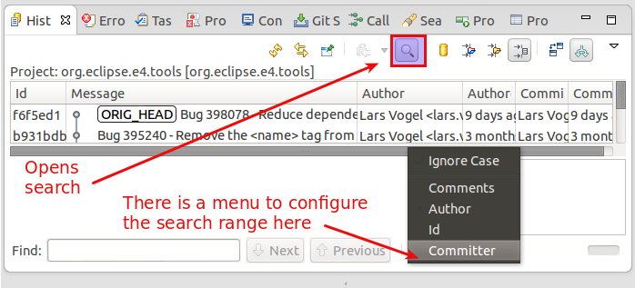
NOTE:The Git Search available in the Search Search menu is much more powerful and consumes less memory since it doesn’t need to also display the history.
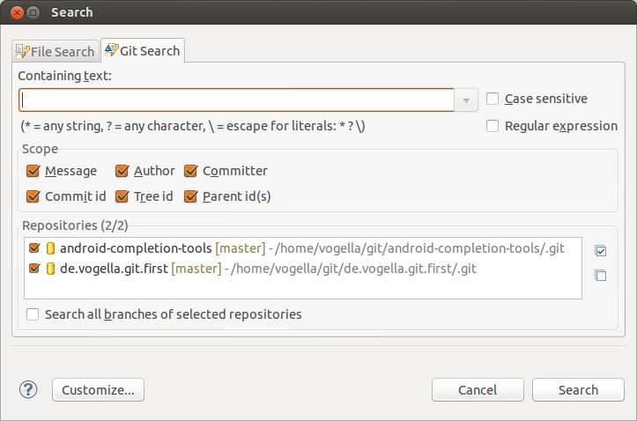

9.5. Showing details of a commit
If you want to see more details about a commit, right-click it and select the Open in Commit Viewer entry.
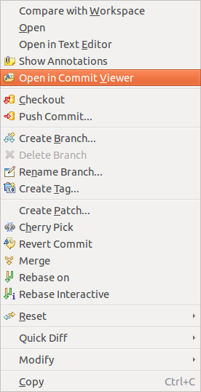
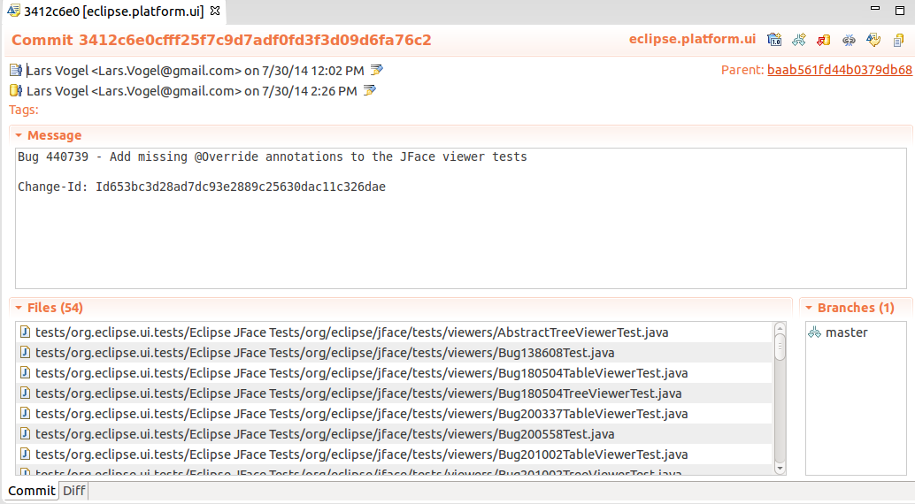

10. Working with Eclipse projects in a Git repository

10.1. Workspace and projects
Eclipse allows working with projects that are not included in the root folder of the workspace.
Using this functionality your projects can be stored in the working tree of a Git repository.

10.2. Adding a new project to a Git repository
To can add Eclipse projects to an Git repository. If you do this the project is moved to the Git repository and linked to from the Eclipse workspace.
A simple way of adding a project to a Git repository is to specify the file location in the New Project wizard. This is depicted in the following screenshot.
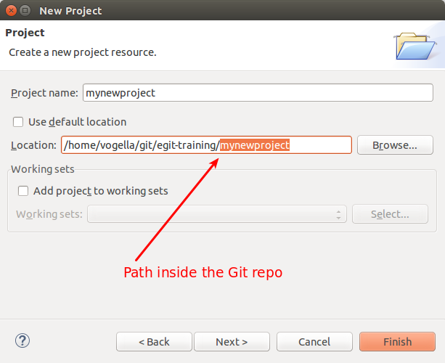
If you add the Git repository to your Git repositories view, you can perform the Git team operations on the files of this repository.
To add a new Eclipse project to an existing Git repository, select the project, right-click on it and select Team Share Git. Afterwards select the desired Git repository.
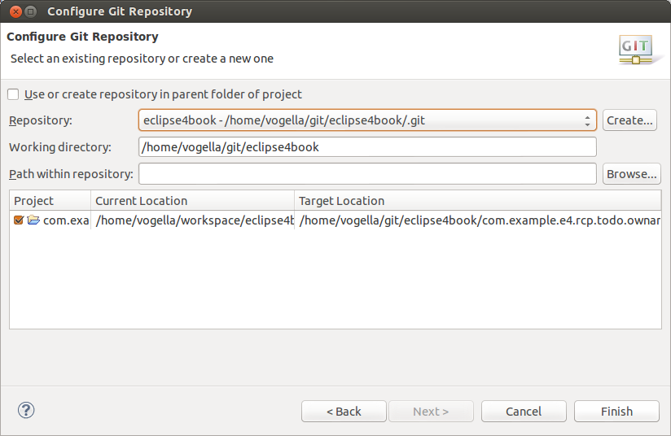
The Eclipse Git functionality moves the projects to the repository. It also imports the project again into your workspace with the adjusted reference on the file system.

11. Clone an existing repository
Eclipse allows you to clone an existing Git repository. Afterwards, you can import existing projects from this repository into your workspace.
Select File Open Projects from File System…​.
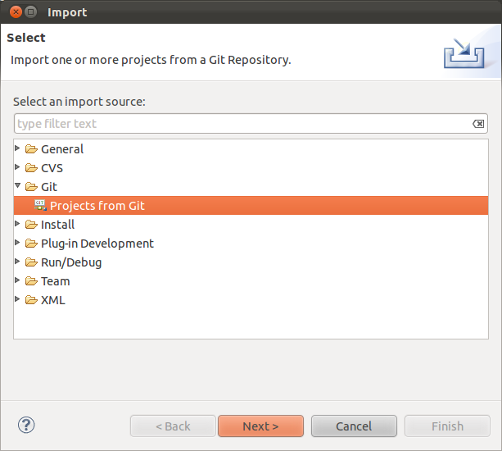
Select URI in the next dialog.
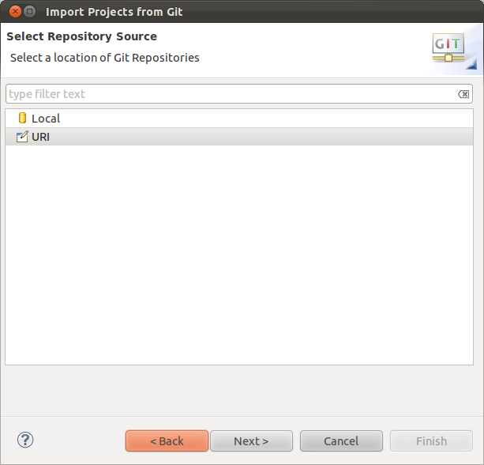
Enter the URL to your Git repository. Git supports several protocols, e.g. git://, ssh:// and https://. You can paste the clone URL to the first line of the dialog, the rest of the dialog is filled based on this data.
Some proxy servers block the git:// and ssh:// protocols. If you face issues, please try to use the https:// or http:// protocol.
For example the following URI can be used to clone the example projects of the Eclipse 4 application development book:
git://github.com/vogella/eclipse4book.git
The above link uses the git protocol, alternatively you can also use the http protocol: http://github.com/vogella/eclipse4book.git
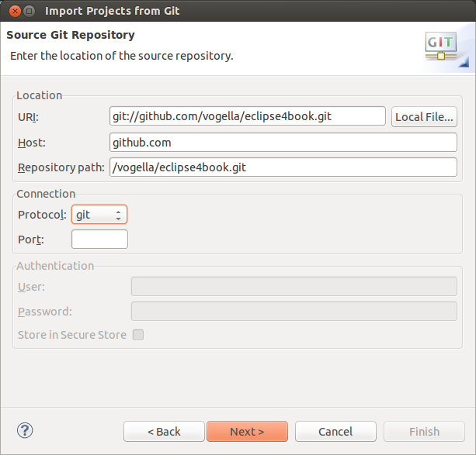
After pressing the Next button the system will allow you to import the existing branches. You should select at least master as this is typically the main development branch.
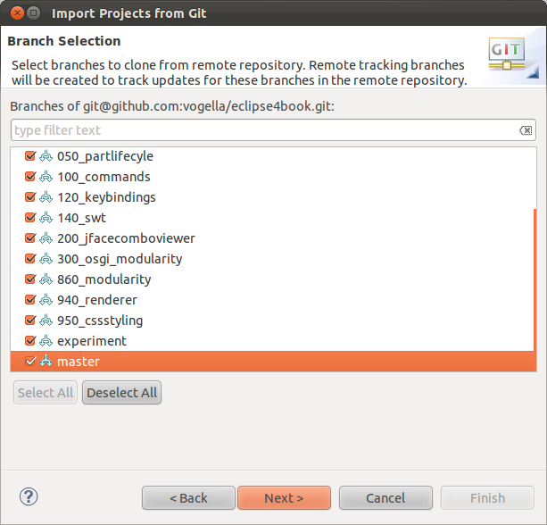
The next dialog allows you to specify where the repository should be copied to and which local branch should be created initially.
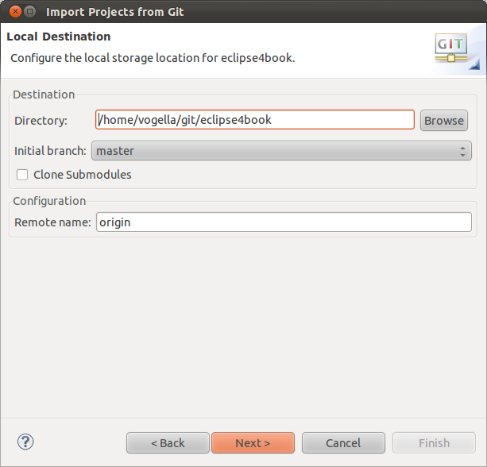
After the Git repository is cloned, Eclipse EGit opens an additional import dialog which allows importing the Eclipse projects from the Git repository.
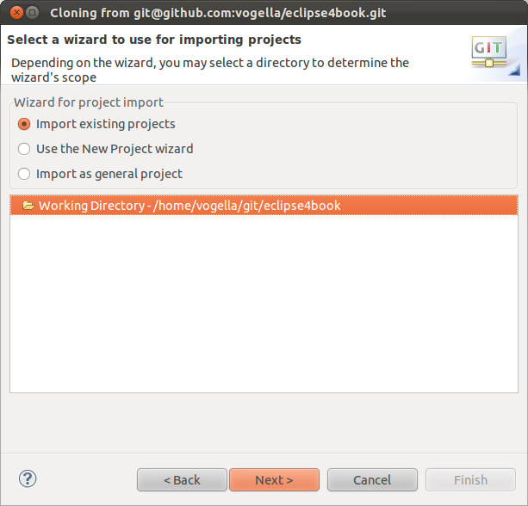
Once this dialog is completed, you have clone the remote repository into a local Git repository. You can use Git operation on these projects.

12. Import projects from an existing repository
If you have already an existing Git repository you can add it to Eclipse and import the Eclipse projects into your workspace via the Select File Import Git Project from Git menu entry.
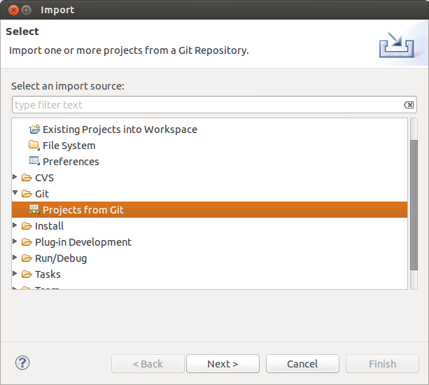
Select Local if you want to important from a local repository or Clone URL if you first want to clone the repository.
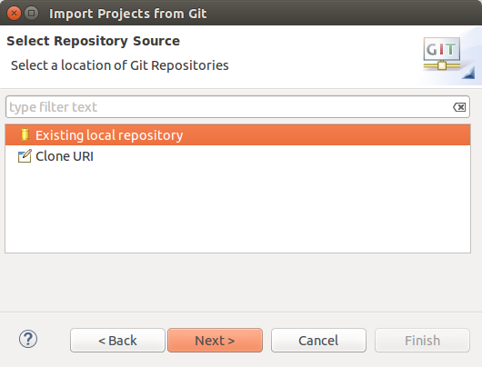
The following screenshot shows several local repositories. To import the project contained in one of them, select one entries and press the Next button. To add a new local repository to this dialog (and the Git repositories view) use the Add…​ button.
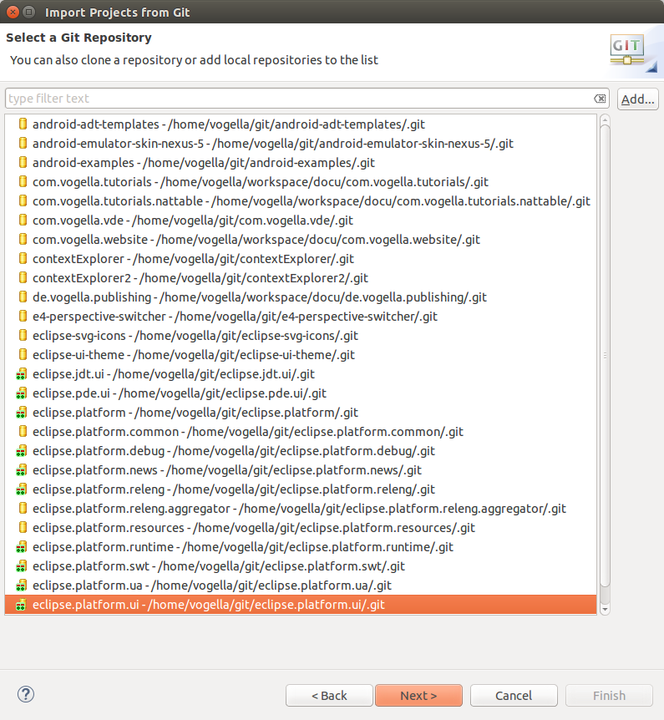
The wizard allows you to import existing projects. After this import the Eclipse IDE makes the projects available and is aware that these projects are part of a Git repository.

13. Performing Git operations in Eclipse

13.1. Pull, push and fetch
You can use the Git Repositories view to pull, push and fetch to remote repositories. Right click on your repository and select the appropriated operation.
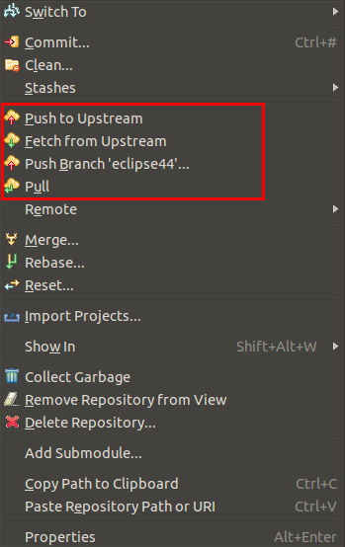

13.2. Basic team operations
Once you have placed a project under version control you can start using team operations on your project. The team operations are available via right-click on your project or file.
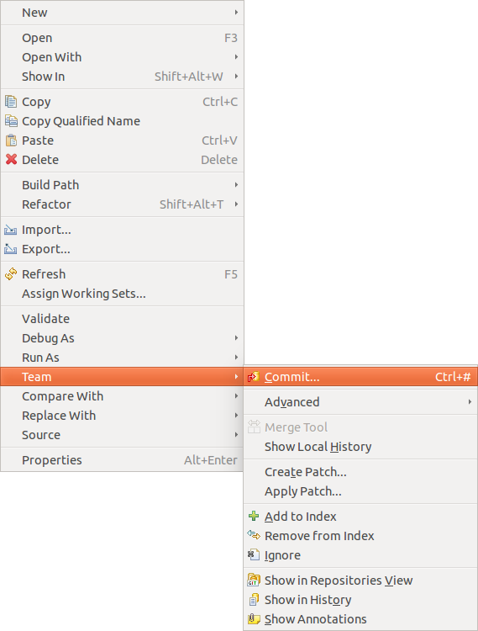
The Team menu is also available from the context menu of an opened editor.
The most important operations are described in the following list. Select:
- Team Add to index, to add the selected resource(s) to the Git index
- Team Commit, to open the commit dialog to create a new commit
- Team Create Patch…​, to create a patch
- Team Apply Patch…​, to apply a patch to your file system
- Team Ignore, to add a file to the .gitignore file
- Team Show in History, to display the history of the selected resources(s)

13.3. Team operations available on the project
If you select a project you can use additional team operations from the context menu.
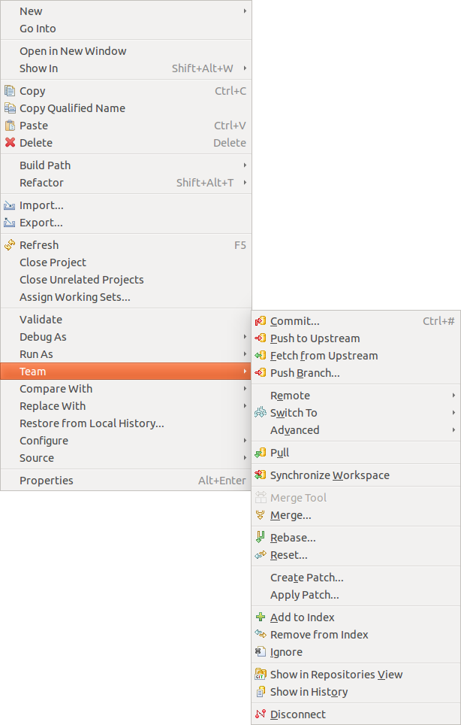
- Team Pull to pull in changes from your remote Git repository
- Team Fetch to fetch the current state from the remote repository
- Team Switch To to checkout existing or create new branches
- Team Push to push changes to your remote Git repository
- Team Tag to create and manage tags.

13.4. Amending a commit
Git amend allows adjusting the last commit. For example you can change the commit message or add another modification.
The Git Staging view allows you to perform the Git amend command via the highlighted button in the following screenshot.
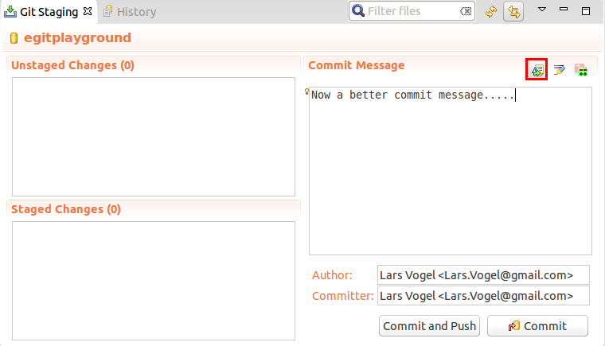

14. Branching in Eclipse
Right-click your project and select Team Branch to create new branches or to switch between existing branches.
You can also switch branches in the History view or the Git repositories view.

15. Starting a merge operation in Eclipse

15.1. Merge
Eclipse supports merging of branches to add the changes committed on one branch into another branch.
Checkout the branch into which you want to merge the changes into and select your project and Team Merge to start the merge dialog.
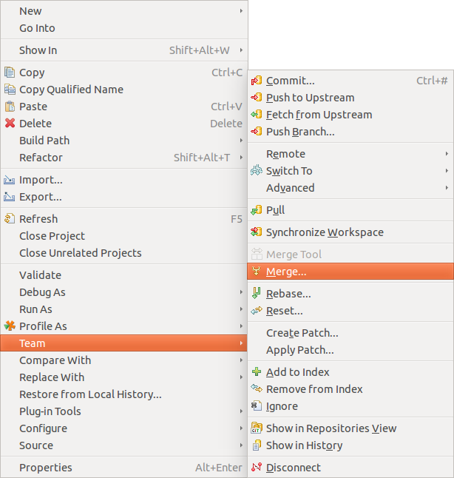
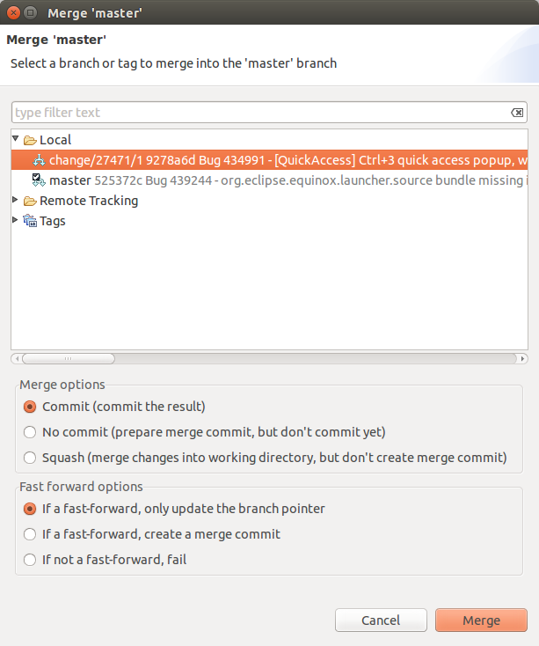

15.2. Solving merge conflicts
If during a Git operation, two changes are conflicting, you have to solve these conflicts manually. Eclipse Git highlights the affected files in the Package Explorer or Project Explorer view.
Eclipse Git supports the resolution of these merge conflicts. To trigger this via the explorer views, right-click on a file with merge conflicts and select Team Merge Tool.
You can also use the Git staging view to find the conflicting files. In large projects this is usually faster than navigating the Package Explorer or Project Explorer view.
This opens a dialog, asking you which merge mode you would like to use. The easiest way to see the conflicting changes is to use the Use HEAD (the last local version) of conflicting files as merge mode. This way you see the original changes on the left side and the conflicting and non-conflicting changes on the right side.
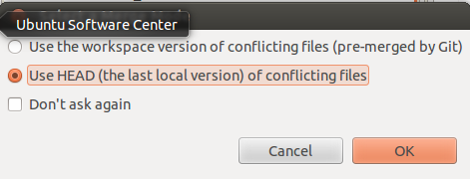
You can manually edit the text on the left side or use the Copy current change from right to left button to copy the changes from right to left.
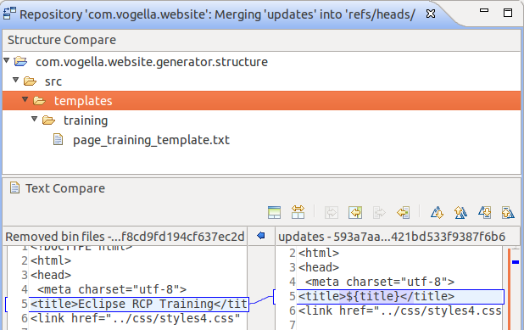
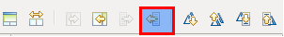
Eclipse also allows to show the common ancestor of both commits to make the merge easier. Press the Hide/Show Ancestor Pane button for that. This is demonstrated by the following screenshots.
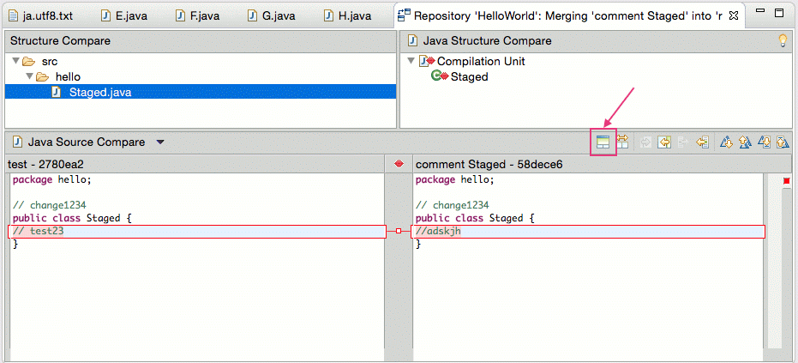
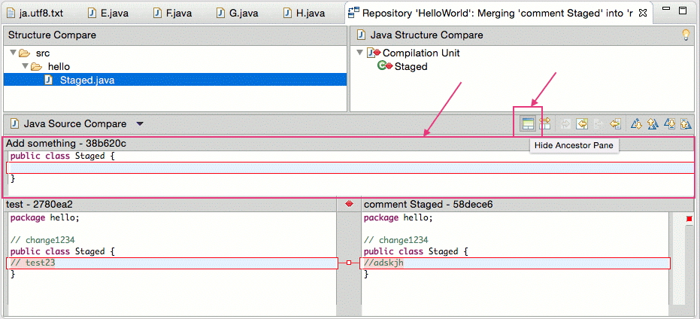
Once you have manually merged the changes, select Team Add from the context menu of the resource to mark the conflicts as resolved and commit the merge commit via Team Commit.

16. Rebasing a branch onto another branch
The Git Repositories view allows you to rebase your currently checkout branch onto another branch.
Right-click on a repository node and select Rebase as depicted in the following screenshot.
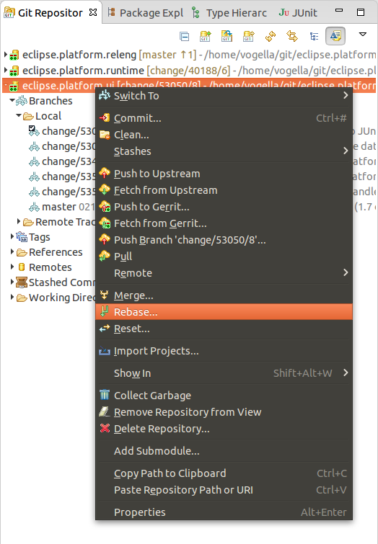
In the following dialog you can select the branch onto which you want to rebase.
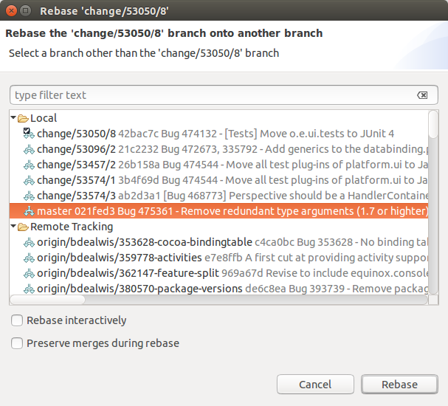
You can also select the branch to rebase onto from the Branches node of the tree directly.
If the rebase was successful a dialog is shown. You have to resolve rebase conflicts if they occur. After resolving them, select Rebase Continue.
If you want to skip the conflicting commit and continue with the rebase operation use Rebase Skip.
To cancel the rebase operation select Rebase Abort.

17. Git reset and Git reflog

17.1. Moving the branch pointer with Git reset
The History view allows you to reset your current branch to a commit. Right-click on a certain commit and select Reset and the reset mode you would like to use.
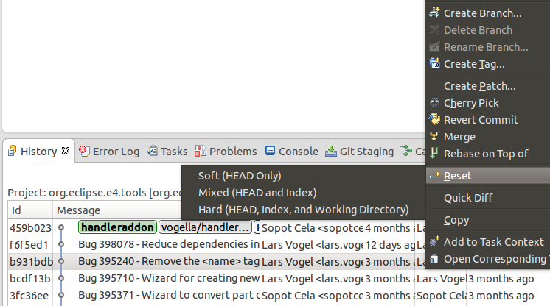

17.2. Finding "invisible" commits with the Reflog view
Commits are not visible in the Git history if they can’t be reached from a branch or tag. This might happen during a reset, commit amend or rebase operation. By default, such invisible commits are removed after two weeks by the Git system.
The Git Reflog view keeps track of the movements of the HEAD pointer and the movements of each branch. This view allows you to find a commit again, e.g., if you used the git reset --hard command to remove certain commits.

18. Using git cherry-pick
In the History view, you can cherry-pick a commit via the context menu.
A combination of git reset and git cherry-pick allows you to move the changes done in a commit to anther branch. Assume you have a bad commit which you would like to remove from the history of branch followed by a good commit. This situation is depicted in the following screenshot.
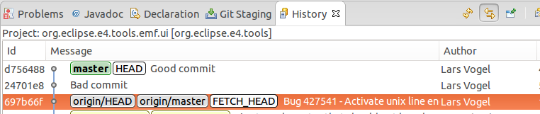
For this you would make a hard reset on the commit of origin/master.
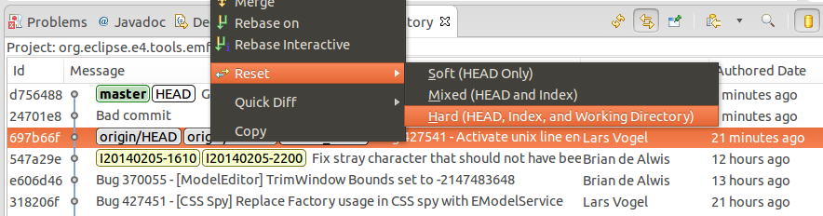
Afterwards you can cherry-pick the good commit.
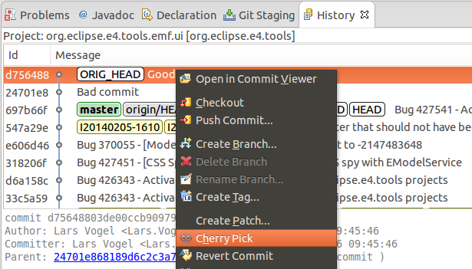
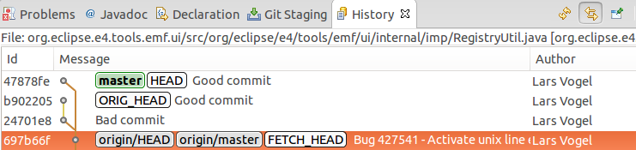
This results in a history without the bad commit.
You can do the same with Adjusting the history with interactive rebase.

19. Creating patches
To create a patch for a set of changes with Eclipse Git, select the resources for which you want to create a patch in the Package Explorer view, right click and select Team Create Patch.
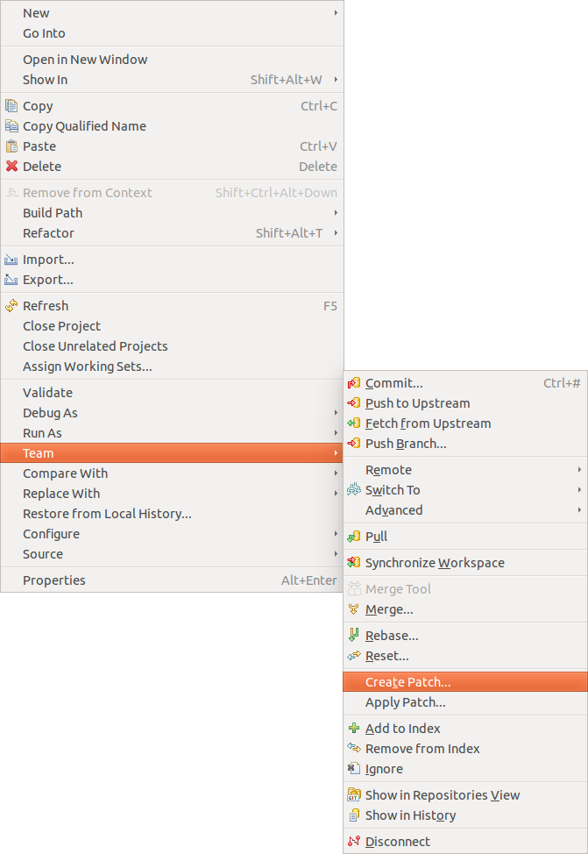
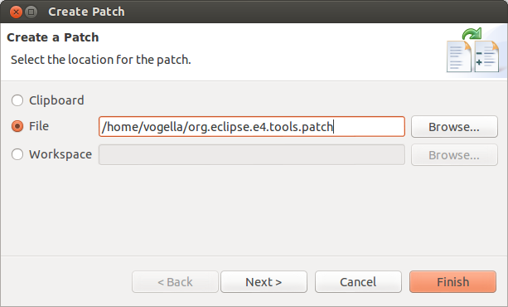
The resulting file can be used to get applied to another Git repository, via Team Apply Patch. You can also apply the patch on a system where Git isn’t installed at all, i.e., you don’t need a Git repository to apply a patch.

20. See Git information line by line (aka git blame)
Eclipse allows to display the information which commit and person change a line. To enable this, right-click on your file and select Team Show Annotations.
Afterwards, you can place the mouse on the left side of the editor. A popup dialog shows the commit information and the change applied by the shown commit.
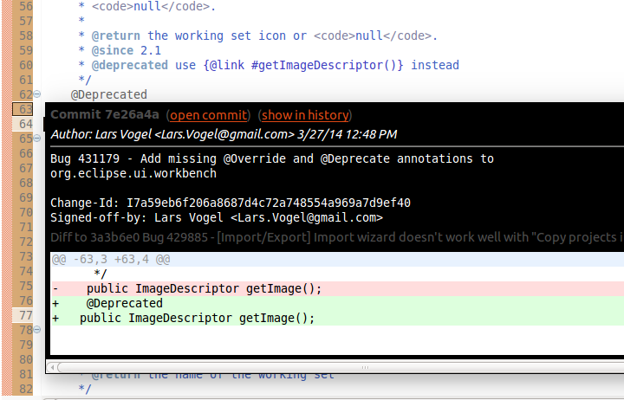
To ignore whitespace changes in the Git blame annotations in Eclipse, select Window Preferences Team Git and select Ignore whitespace changes.

21. Stash via the Git repository view
The git stash command is available in the Git repositories view. Right-click on your Git repository and select Stash Changes.
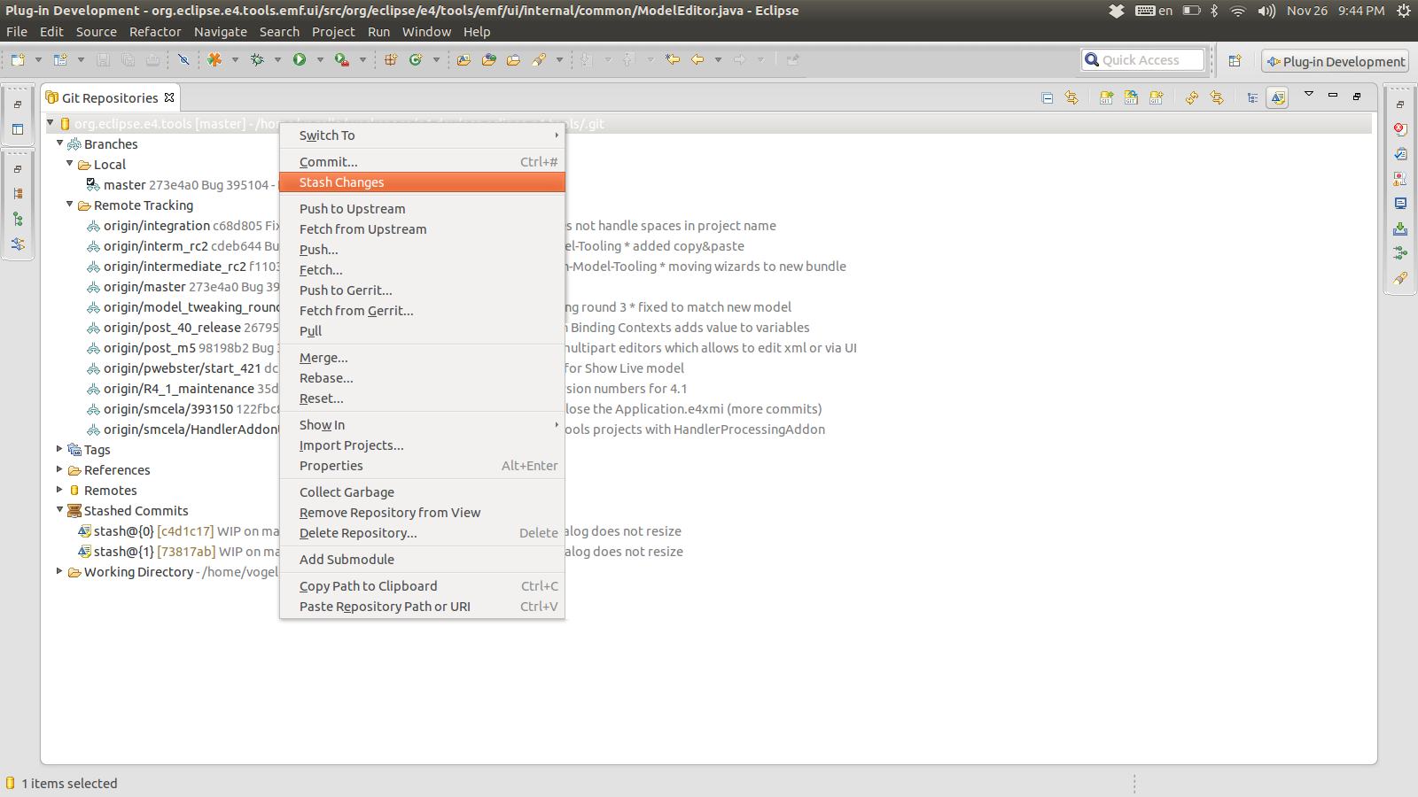
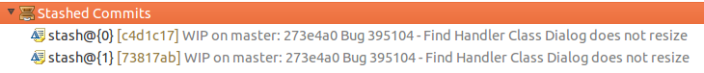
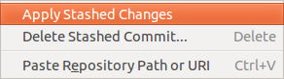

22. Adjusting the history with interactive rebase

22.1. Support for interactive rebase in Eclipse
Git allows to adjust the existing commit history the interactive rebase functionality. You can start an interactive rebase via the History view. The execution is done via the Git Interactive Rebase view.

22.2. Actions available via the History view
To reword a commit, right-click on it in the History view and select Modify Reword to change the commit message.
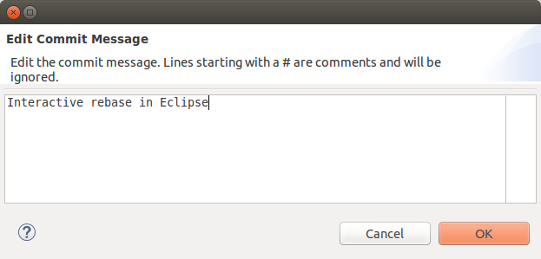
You can squash several commits by selecting them in the History view. Select afterwards the Modify Squash menu entry from the context menu.
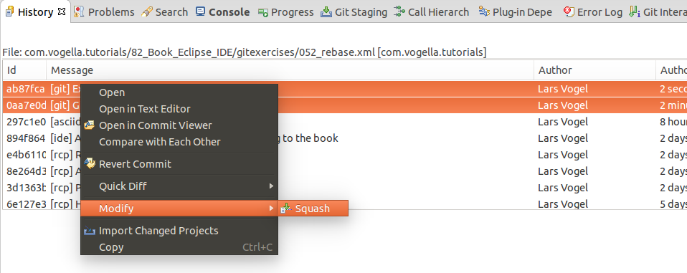
The above options are simplified ways to do an interactive rebase.

22.3. Using the Git Interactive Rebase view
The Git Interactive Rebase view allow you perform the full interactive rebase functionality. This includes changing the order of commits or combining, removing and adjusting commits.
To start the full interactive rebase open the History view and click Rebase Interactive on the context menu. Select the last commit preceding the oldest commit you want to rewrite. Often this is the one origin/master points to.
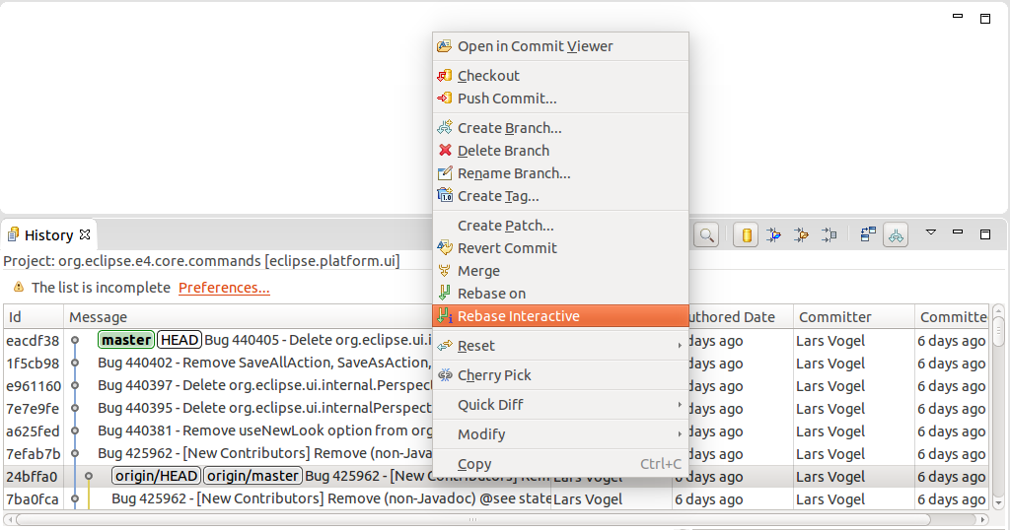
This opens the Git Interactive Rebase view. It shows the rebase plan populated with the commits to be modified. They are sorted in topological order of the sequence in which they will be processed. This order is the reverse order which you see via the git log command or in the History view. The initial action for all commits is "Pick".
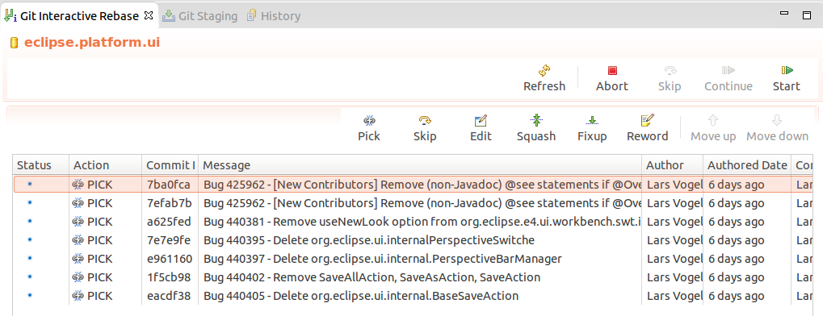
The Eclipse Git tooling supports the following actions.
Table 2. Interactive rebase actions
Action | Description
pick | includes the selected commit, moving pick entries enables reordering of commits
skip | removes a commit
edit | amends the commit
squash | combines the changes of the commit with the previous commit and combines their commit messages
fixup | squashes the changes of a commit into the previous commit discarding the squashed commit’s message
reword | similar to pick but allows modifying the commit message
Use this view to finalize the rebase plan. For example, you can reorder commits with the arrow buttons and select the rebase action you want to apply to the commit. The following screenshot demonstrates a possible selection.
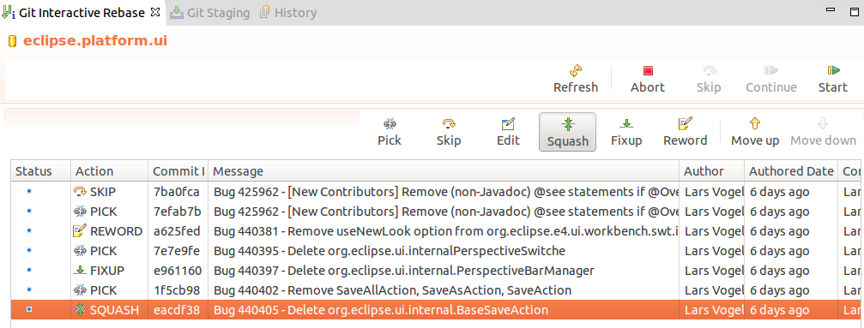
When the rebase plan is finalized, click the Start button to start the interactive rebase command. Eclipse Git processes the plan. It stops at all commits with an action which needs user feedback. For example, the reword action which requires entering the new commit message. The dialog for changing the commit message is depicted in the following screenshot.
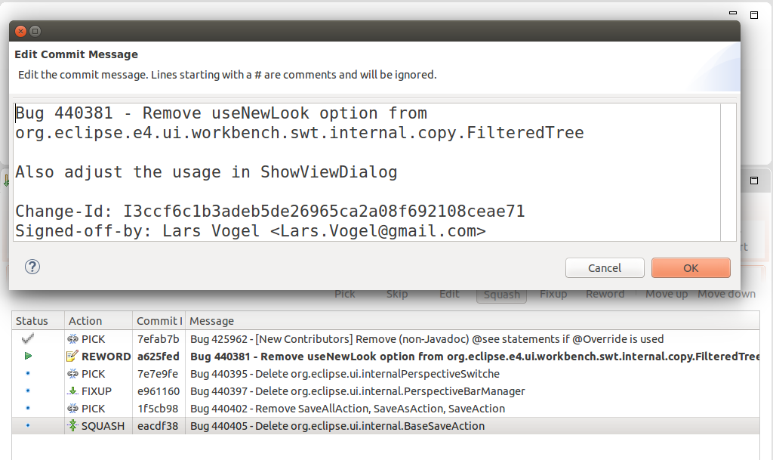
Here is the result of the rebase operation displayed in the History view.
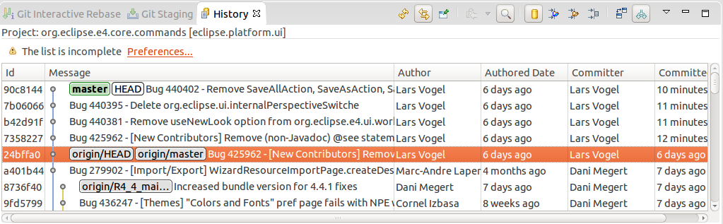
If something goes wrong during the rebase operation, you can select Abort in order to stop the rebase operation and roll back to the starting point.

23. Using Eclipse Git with GitHub

23.1. Clone project
Copy the URL from GitHub and select in Eclipse from the menu the File Import Git Projects from Git
Eclipse fills out most of the fields based on the URL in the clipboard. Enter your user and password to be able to push to GitHub. Alternative you can also use an SSH key. You can configure Eclipse to know your SSH via the Window Preferences General Network Connection SSH2 preference setting. This setting is depicted in the following screenshot.
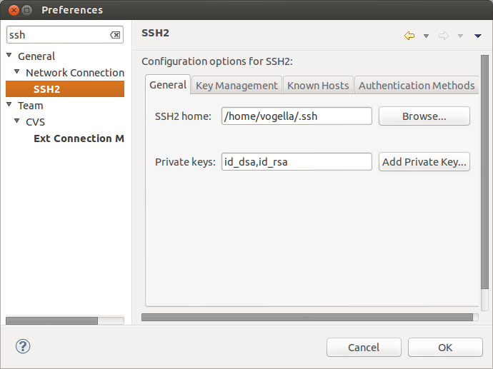

23.2. Push changes
After you made changes and committed them to your local repository, you can select Team Push to upstream on the project folder, to push your changes to your GitHub. This requires write access to the GitHub repository.

24. Eclipse support for SSH based authentication
You can create an SSH key pair in Eclipse for SSH based communication. This can be done via Window Preferences General Network Connection SSH2.

25. Eclipse integration with GitHub
=== The Eclipse Mylyn plug-in
Eclipse Mylyn provides task integration for GitHub issues, GitHub pull and Gist (short text snippets) into the Eclipse IDE.
There is a GitHub connector for Mylyn available, please see GitHub Mylyn User Guide for details.
You install it via Help Install new Software and the update site of your release.
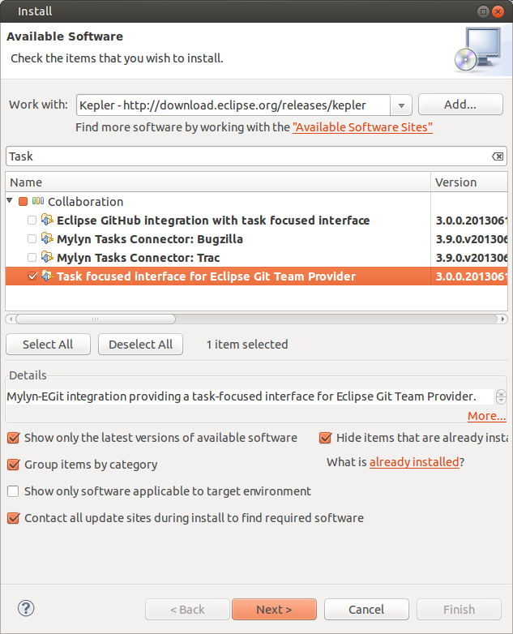

25.1. GitHub issue integration
You can integrate your GitHub issues into Eclipse via File Import…​ Task GitHub Task Repositories and by following the wizard.
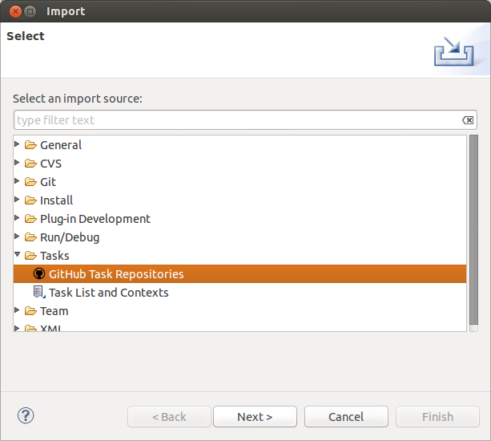

25.2. Manage pull requests in Eclipse
You can integrate your pull requests at GitHub into Eclipse by creating a new query from the Task List view. This is demonstrated via the following screenshots.
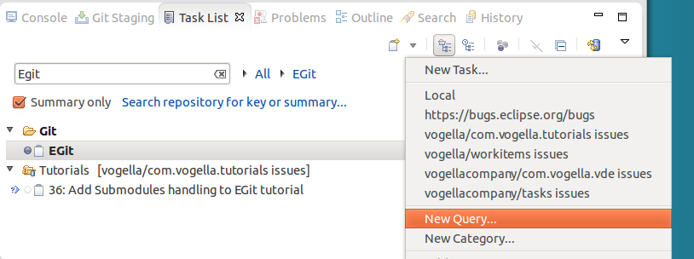
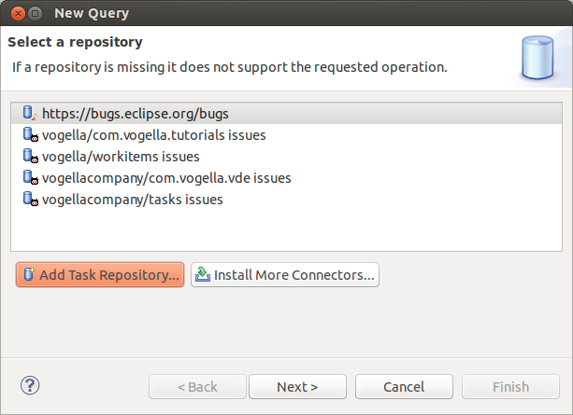
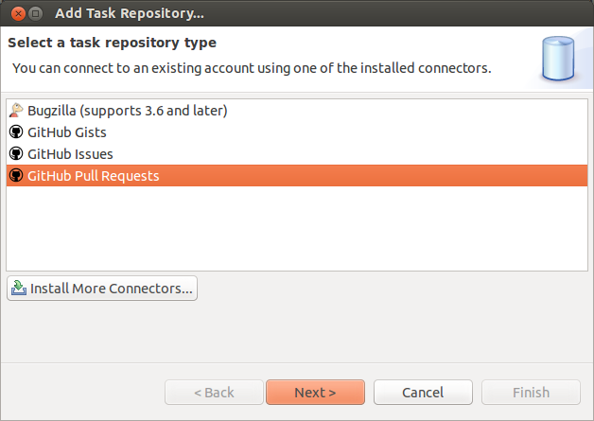
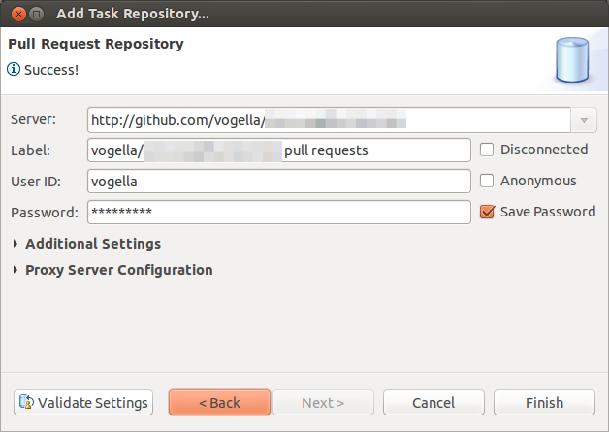
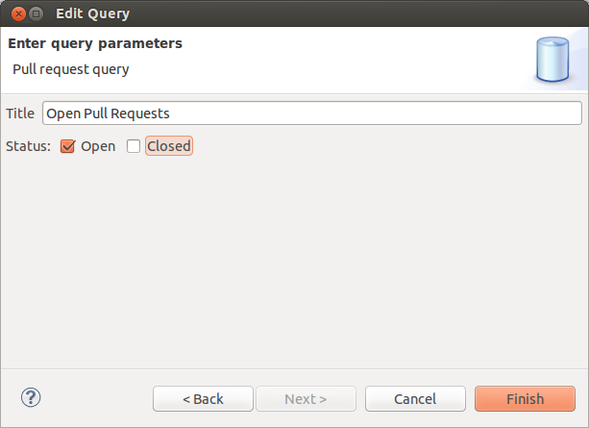
NOTE:Unfortunately the GitHub connect does currently not support that you merge the pull request.

25.3. Import projects directly from GitHub
You can also import now directly projects from GitHub repositories.
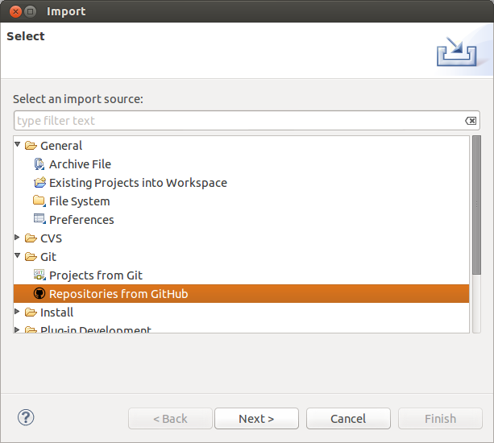

25.4. More infos about the GitHub Mylyn integration
For a detailed description of the Mylyn and EGit integration please see the following webpage.
http://wiki.eclipse.org/EGit/GitHub/UserGuide

26. Writing good commit messages

26.1. Importance of Git commit messages
A commit adds a new version to the repository. This version is described by a commit message.
The _commit message_describes the changes recorded in a commit. It should help the user to understand the history of the repository.
A commit message should therefore be descriptive and informative without repeating the code changes.

26.2. Guidelines for useful commit messages
A commit message should have a header and a body. The header should be less than 50 with a maximum of 72 characters. The body should wrap its text at 72. The body is separated from the header by an empty line.
This ensures that the commit message is displayed well on the command line or in graphical tools.
The body describes the reason why the change was made. The changes in the file can be reviewed with the help of Git.
The commit message should be in present tense, e.g., "Adds better error handling" instead of "Added better error handling".
The last paragraph can also contain metadata as key-value pairs. This data is also referred to as the commit message footer.
This metadata can be used to trigger a certain behavior. For example, the Gerrit code review system uses the Change-Id key followed by a change-id. This changed id is used to identify to which review the message belongs.
The commit message footer can also have e.g., 'Signed-off-by'. Or it may link to a bug tracking system, e.g., 'Bug: 1234'.

26.3. Example message
The following can serve as an example for a commit message.
Short summary (less than 50 characters)

Detailed explanation, if required, line break at around 72 characters
more stuff to describe...

Fixes: bug #8009
Change-Id: I26b5f96ccb7b2293dc9b7a5cba0760294afba9fd

26.4. Good and bad example for a Git history
The following listing shows the output of the git log --oneline command of a Git repository with bad commit messages. The first value in each line is the shortened SHA-1, the second the commit message. This history is not useful.
21a8456 update
29f4219 update
016c696 update
29bc541 update
740a130 initial commit
The next listing shows the history of another Git repository in which better commit messages have been used. This history already gives a good overview about the activities.
7455823 Adds search and filter to the model editor tree
9a84a8a Missing DynamicMenuContribution in child selector
952e014 Fixes spelling error in Toolbar/Add child
71eeea9 Adds option to import model elements from legacy RCP
123672c New Application wizard is missing dependencies
97cdb9a Creates an id for handlers
The above example also adds the corresponding bug number to the commit message. Some teams (like the Eclipse platform team) use this approach, others prefer to add the bug number to the commit messages.

27. Exercise: Working with a local Git repository in Eclipse
The following section explains how to create a local Git repository for one project with Eclipse. This allows you to keep track of your changes in the project. It also allows you to revert to another state at a later point in time.

27.1. Create a new Git repository via Eclipse
Open the Git Repositories view and select the Create a new Git repository and add it to this view option.
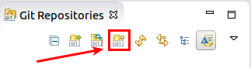
Select a new directory outside of your workspace. By convention this directory is a subdirectory in the git folder of the users home directory.
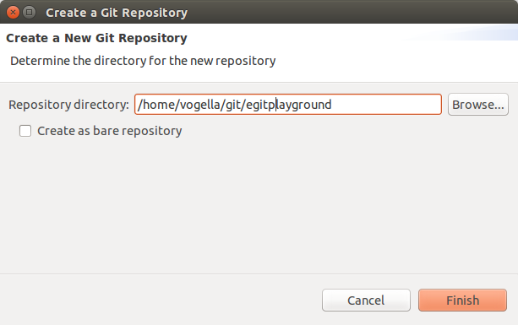
If you press the Finish button this dialog creates the directory and adds a reference to the new Git repository to the Git Repositories view.
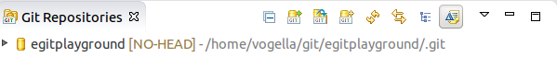

27.2. Create .gitignore file
You want to configure Git to ignore the generated bin folder with the class files. Create for this purpose a .gitignore file in your Git repository with the following content.
Unfortunately Eclipse Git does not allow to create a file directly in the repository. You have to do this step outside of the Eclipse IDE, either via the command line or via your system project explorer.
Recent versions of MS Windows decided to prevent you from renaming a file in the file explorer without using a file extension. Create a file in Notepad or Editor (new name for Notepad) and select Save-As. Ensure you have removed the .txt extension.
bin
All files and directories which apply to the pattern described in this file will be ignored by Git. In this example, all files in the bin are ignored.
You can also configure Eclipse to automatically ignore derived resources, e.g., class files via the Window Preferences Team Git Projects Automatically ignore derived resources .. setting.

27.3. Creating an Eclipse project
Create a new Java project called com.vogella.git.first in Eclipse. Create the com.vogella.git.first package and the following class.
package com.vogella.git.first;

public class GitTest {
public static void main(String[] args) {
System.out.println("Git is fun");
}
}

27.4. Put project under version control
To put your new project under version control with Git, right-click on your project, select Team Share Project Git.
Depending on your installation you may have to select that you want to use Git as a version control system.
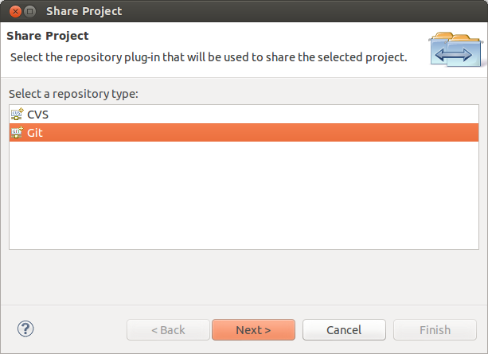
On the next dialog select your existing Git repository from the drop-down list and press the Finish button.
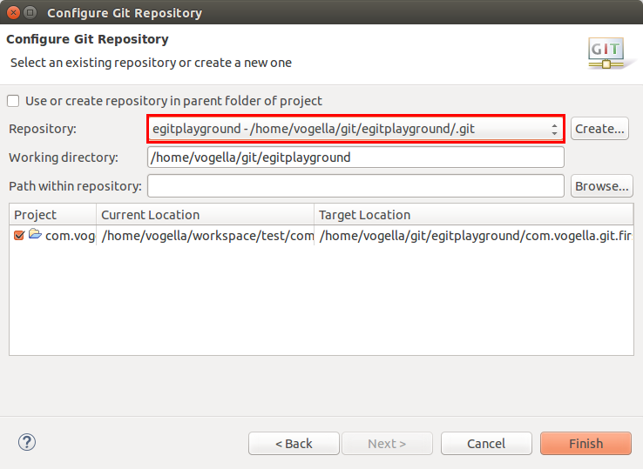
This moves the project to your Git repository. The following screenshot shows the generated directory structure. The .git directory contains the Git repository, the other directories contain the files of the working tree.
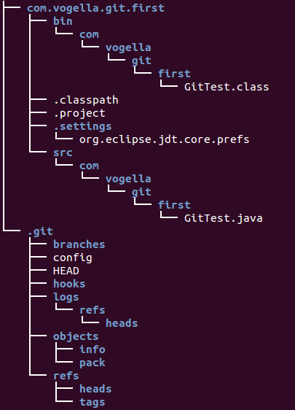

27.5. Using the Git Staging view for the initial commit
Open the Git Staging view, if it is not yet open via Window Show View Other…​ Git Git Staging. In this view drag all files into the Staged Changes area, write a meaningful commit message and press the commit button.

27.6. Using the Git Staging view for committing changes
Change the System.out.println message in your GitTest class.
package com.vogella.git.first;

public class GitTest {
public static void main(String[] args) {
System.out.println("Git is cool");
}
}
Create a new file called Readme.md.
Commit the changes of the GitTest class but do not add and commit the Readme.md file to the Git repository.
In the Git Staging view drag only the GitTest class into the Staged Changes area, write a meaningful commit message and press the commit button.
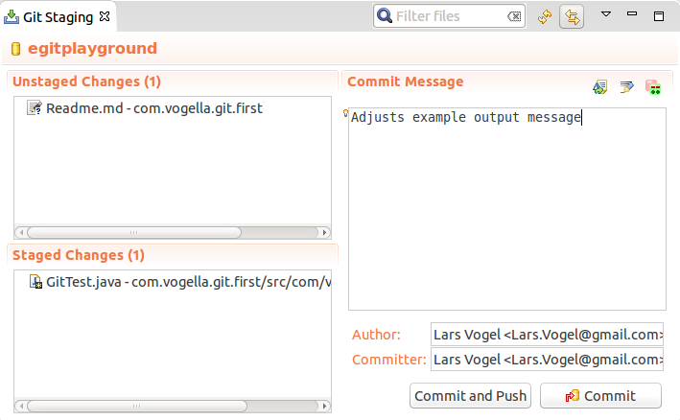
This change is now also stored in your local Git_repository. The Readme.md file is neither staged nor committed to the Git repository.

27.7. Commit more files
Commit the Readme.md file. By now you should know that you have to stage the file and commit it.

27.8. Review your commit history via the History view
Open the History view to browse the commit history of your repository. Review which files were included in your individual commits.
In the History view click all toggle buttons as shown in the screenshot
- Link with Editor and Selection
- Show all changes in repository containing the selected resources
- Compare Mode
- Show all Branches and Tags
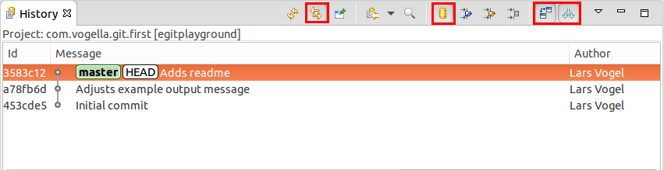

27.9. Open an older version with the current version of a file via the History view
Open the version for the first commit of GitTest via the History view.
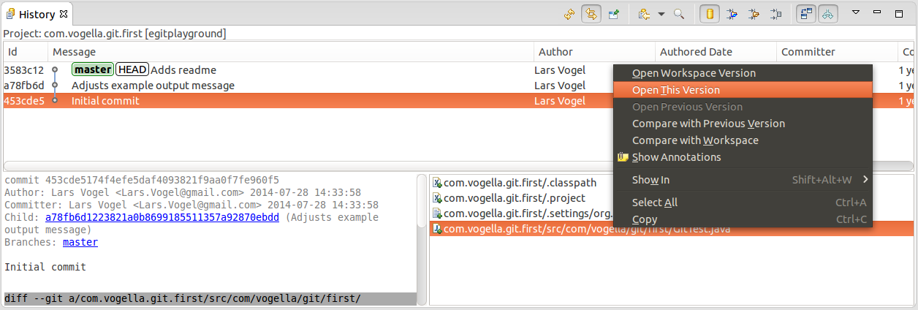

27.10. Add more projects to your Git repository
You can of course have more than one Eclipse project in your Git repository. To validate that, create two more Java projects called com.vogella.egit.multi.java1 and com.vogella.egit.multi.java2. Create at least one Java class in each project.
Afterwards select both projects, right-click on them and select Team Share Project…​ Git. If asked by the Eclipse IDE, select that you want to use Git.
Select your Git repository you created in this exercise and add both projects to this repository. Press the Finish button.

27.11. Validate the project move and commit changes
Afterwards validate that the projects have been moved. You can checking your workspace directory and your Git repository directory via a file explorer. You see that the projects have been moved from there original location to the Git repository.
The changes have not yet been commit. Now commit all files in the two projects to your Git repository.

28. Contributing to EGit - Getting the source code
EGit is self-hosted on git://git.eclipse.org.
See EGit contributor guide for a description how to work with the EGit and JGit source.

29. Eclipse Git Resources
Eclipse Git User Guide
Contributor guide for the Eclipse Git project
Different update sites for Eclipse Git

30. vogella training and consulting support


Online Training
fitness_center

Onsite Training
group

Consulting

Appendix A: Copyright, License and Source code
Copyright © 2012-2018 vogella GmbH. Free use of the software examples is granted under the terms of the Eclipse Public License 2.0. This tutorial is published under the Creative Commons Attribution-NonCommercial-ShareAlike 3.0 Germany license.
Licence
Source code
Support free tutorials

Version 4.3
Last updated 2018-10-26 10:59:58 CEST

